**Risks after burns involving the immune response:**

**Excessive inflammation leading to SIRS**

Excessive immune activation can lead to a systemic inflammatory response syndrome (SIRS) culminating in distant tissue damage and multiple organ dysfunction. Loads of pro-inflammatory cytokines are produced after a severe burn, promoting vascular permeability. This increased permeability can lead to a neutrophilic attack on distant blood vessels, allowing blood to flood end organs leading to organ failure. Excessive neutrophilic inflammation is an early hallmark of SIRS but there is significant involvement of the macrophage during the initial phase of the inflammatory response, particularly mediated by their production of pro-inflammatory cytokines.

**Burn infection**

The loss of the natural barrier to infection, coagulated protein and other microbial nutrients in the burn wound, combined with avascularity of the wound, can lead to microbial colonization. In some patients, colonization is followed by invasion of microorganisms, giving rise to burn wound infection.

If this is interesting for the project, I can try simulating these processes using the HIIS model, by adjusting the vascular permeability, pro-inflammatory cytokines and neutrophil/macrophage setups.

**For example:**

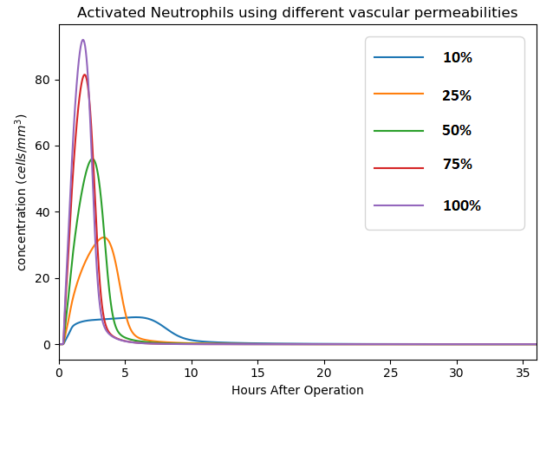

Plot showing the activation of neutrophils using different vascular permeabilities (percentages of the normal permeability value, sort of simulating less vascularity of the wound)

**Some ideas on measuring bacterial infection risk when suppressing inflammation in HIIS model. (the main idea we discussed after the meeting last week)**

**Suppressing inflammation for better healing**

When both of these previously mentioned risks are controlled, we can influence the inflammatory response to improve the wound healing and have less scarring. A large inflammatory response of adults results in faster healing but causes more extensive scarring. It is clear that prolonged and/or excessive inflammation in the early stages of burn injury leads to excessive fibrosis and scarring. This scarring is caused by excessive TGFB and collagen synthesis caused by the inflammation.

For ‘scarless healing’ we need: Few inflammatory cells, many anti-inflammatory cytokines, few pro-inflammatory cytokines, low TGFB levels and low collagen type 1 levels.

To suppress the inflammatory response, the cytokine levels should be adjusted:

Ideally this would be the case:

Lower Pro-inflammatory cytokine levels-> lower epithelial permeability -> Lower Neutrophil activation -> Lower macrophages activation -> lower TGFB levels -> lower collagen levels -> less scarring

Or

Higher anti-inflammatory cytokine levels -> Inhibit activation of neutrophils and macrophages -> lower TGFB levels -> lower collagen levels -> less scarring

ACH controls CH in the model, high ACH means low CH, so will suppress inflammation.

ACH = anti-inflammatory cytokine

CH = pro-inflammatory

However, suppressing inflammation can possibly lead to bacterial infections as less inflammatory cells will be recruited to the wound site full of bacteria. We need a way to measure this risk.

**Biomarkers of bacterial infection risk**

White blood cell (neutrophils, lymphocytes, eosinophils, monocytes, basophils) count (WBC), absolute neutrophil count (ANC), erythrocyte sedimentation rate (ESR), C-reactive protein count (CRP), bacteria – neutrophil/macrophage ratios, and several other cell type counts have been recognized as potential markers of increased risk on bacterial infections. In the HIIS model, the probability on acute bacterial infection can only be measured using absolute neutrophil count, as the rest of the potential markers are not included in the model. HIIS model does not include a numerical bacteria count, so we cannot use bacteria – neutrophil/macrophage ratios to investigate infection risks.

The neutrophil count usually is between 1.6 and 7.4 x 109/L blood.Because each neutrophil in suspension can kill >20 bacteria, there is a large apparent excess in neutrophil capacity to kill bacteria. Yet, in neutropenic hosts (low neutrophilic counts), bacteria survive and grow in blood. There is a correlation between the neutrophil count and the risk of bacterial infection. Neutropenia is low concentration of neutrophils in the blood. Neutropenia can be measured using absolute neutrophil count (ANC) in the blood. Congenital neutropenia is determined by blood neutrophil counts ANC < 0.5 × 109/L. An absolute count of 0.5 – 1.0 × 109/L is associated with moderately increased risk of infections. A count below 0.5 × 109/L is invariably associated with serious infection. When neutropenia is present, the inflammatory response to such infections is ineffective.

So, HIIS model does include absolute neutrophil counts. If we can create continuous influx of resting neutrophils, we will be able to use the ANC as bacterial infection risk factor. We can then start playing around with the cytokine levels to see how this influences the ANC and what the risk of this on infections is.

Or induce some sort of numerical bacterial variable, which can be used to calculate a bacteria – neutrophil/macrophage ratios to see if bacteria can grow or are destroyed.

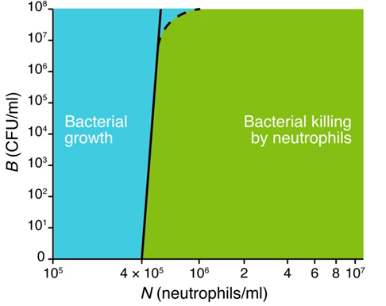

1 Novac RE: The beleaguered band count. Clin Lab Med 1993; 14: 895–903.

Dutcher TF: Leukocyte differentials: are they worth the effort? Clin Lab Med 1984; 4: 71–87.

3 Rimarenko S, Castella A, Salzberg MR, Strand CL: Evaluation of the automated leukocyte differential count in emergency department patients. Am J Emerg Med 1987; 5: 187–189.

4 Shapiro MF, Greenfield S: The complete blood count and leukocyte differential count: an approach to their rational application. Ann Intern Med 1987; 106: 65–74.

5 Krause J: Automated differentials in the hematology laboratory. Am J Clin Pathol 1990; 93(suppl):S11–S16.

6 Wenz B, Gennis P, Canova C, Burns ER: The clinical utility of the leukocyte differential in emergency medicine. Am J Clin Pathol 1986; 86: 298–303.

7 College of American Pathologists: College of American Pathologists Survey Manual. Northfield, College of American Pathologists, 1994, pp 37–38.

8 Todd JK: Childhood infection: diagnostic value of peripheral white blood cell and differentiated cell count. Am J Dis Child 1974; 121: 810–816.

9 Bone RC. Toward a theory regarding the pathogenesis of the systemic inflammatory

response syndrome: What we do and do not know about cytokine regulation. Critical Care

Medicine. 1996;24(1):163-172

10 Christman JW, Lancaster LH, Blackwell TS. Nuclear factor kappa B: A pivotal role in the

systemic inflammatory response syndrome and new target for therapy. Intensive Care

Medicine. 1998;24(11):1131-1138

11 Costantini TW, Peterson CY, Kroll L, Loomis WH, Putnam JG, Wolf P, et al. Burns, inflammation, and intestinal injury: Protective effects of an anti-inflammatory resuscitation strategy. The Journal of Trauma. 2009;67(6):1162-1168

12 Nielson CB, Duethman NC, Howard JM, Moncure M, Wood JG. Burns: Pathophysiology of

systemic complications and current management. Journal of Burn Care & Research. 2017;

38(1):e469-e481

**Continuous influx of neutrophils**

The normal human neutrophil production rate is 0.85 to 1.6 × 109 cells/kg per day. The HIIS model uses 80 kg.